



UIPath RPA Deployment

Process Definition Document - (PDD)

Veterans Evaluation Services

**Document History**

|  |  |  |  |  |  |  |
| --- | --- | --- | --- | --- | --- | --- |
| Date | Version | Role | Name | Organization (Dept.) | Function | Comments |
| 05.29.2019 | 1.0 | Author | Gayathri Komma | *Tecnics* | *Team Lead* | Created document v 1.0 |
|  | 2.0 |  |  |  |  |  |
|  | 3.0 |  |  |  |  |  |

**Document Approval Flow**

|  |  |  |  |  |  |
| --- | --- | --- | --- | --- | --- |
| Version | Flow | Role | Name | Organization (Dept.) | Signature and Date: |
| **1.0** | **Document prepared by** |  |  |  |  |
| **1.0** | **Document Approved by:** |  |  |  |  |
| **1.0** | **Document Approved by:** |  |  |  |  |

Contents

**1.** **Introduction** 4

1.1 Purpose of the document 4

1.2 Objectives 4

1.3 Process key contact 4

1.4 Minimum Pre-requisites for automation 5

**2.** **AS IS process description** 5

2.1 Process Overview 5

2.2 Applications used in the process 6

2.3 AS IS Process map 6

2.4 Detailed AS IS Process Steps 7

EMS Application 7

VA Environment 7

Local environment 7

3. To BE Process Description 8

3.1 TO BE Detailed Process Map 8

3.2 Detailed TO BE Process Steps 8

3.3 Parallel Initiatives/ Overlap (if case) 10

3.4 In Scope for RPA 10

3.5 Out of Scope for RPA 11

3.6 Business Exceptions Handling 11

3.7 Reporting 12

**4.** **Other Observations** 13

# **Introduction**

## Purpose of the document

The Process Definition Document outlines the business process chosen for automation using UiPath Robotic Process Automation (RPA) technology.

The document describes the sequence of steps performed as part of the business process, the conditions and rules of the process prior to automation and how they are envisioned to work after automating it, partly or entirely. This specifications document serves as a base for developers, providing them the details required for applying robotic automation to the selected business process.

## Objectives

The business objectives and benefits expected by the Business Process Owner after automation of the selected business process are:

* Automate the process of downloading the files (pdfs) from VA Server to VES Server.
* Merging the PDFs into single PDF file.
* Reduce processing time per item by 80 %
* Better Monitoring of the overall activity by using the logs provided by the robots

## Process key contact

The specifications document includes concise and complete requirements of the business process and it is built based on the inputs provided by the **process** **Subject Matter Expert (SME)/ Process Owner.**

The **Process Owner** is expected **to review it and provide signoff for accuracy** and completion of the steps, context, impact and complete set of process exceptions. The names have to be included in the table below.

|  |  |  |  |
| --- | --- | --- | --- |
| *Role* | *Name* | *Contact details*  *(email, phone number)* | *Notes* |
| **Process SME** | Stalin |  | Point of contact for questions related to process details & exceptions |
| **Process Reviewer** | Michael Vu |  | Point of contact for questions related to process details & exceptions |
| **Process Owner/ Approver for production** | Don Mai |  | Escalations, Delays,etc |

## Minimum Pre-requisites for automation

1. Orchestrator and UiPath Studio
2. Microsoft SQL server instance
3. Microsoft Windows IIS Services with SSL Certificate
4. Identify and implement appropriate credentials and administrative access for appropriate systems
5. Availability of key project resources for duration of project- ensuring all parties remain engaged and provide requested information in a timely manner
6. Test Data to support development

# **AS IS process Description**

## Process Overview

General information about the process selected for RPA prior to automation.

|  |  |  |
| --- | --- | --- |
| # | Item | Description |
| 1 | **Process full name** | Downloading Claims |
| 2 | **Process Area** |  |
| 3 | **Department** |  |
| 4 | **Process short description**  (operation, activity, outcome) | Operators manually download these records from VBMS and maintain it in EMS application in VES Server to process the claims. |
| 5 | **Role(s) required for performing the process** |  |
| 6 | **Process schedule and frequency** | Daily, Monday to Friday, 9 am – 6 pm |
| 7 | **# of items processes /reference period** | ~48/ day per operator on a business day |
| 8 | **Average handling time per item** | 20 min |
| 9 | **Peak period (s)** |  |
| 10 | **Transaction Volume During Peak period** |  |
| 11 | **Total # of FTEs supporting this activity** | 40 |
| 12 | **Expected increase of volume in the next reference period** |  |
| 13 | **Level of exception rate** |  |
| 14 | **Input data** | File number of the veteran |
| 15 | **Output data** | Merged PDF file |

## Applications used in the process

The table includes a comprehensive list all the applications that are used as part of the process automated, at various steps in the flow.

|  |  |  |  |  |  |
| --- | --- | --- | --- | --- | --- |
| # | Application name & version | System  Language | Thin/Thick Client | Environment/  Access method | Comments |
| 1 | EMS | EN | Thick Client | Citrix |  |
| 2 | VBMS | EN | Thick Client | Citrix |  |

## AS IS Process map

**High Level As-Is Process Map:**

This chapter depicts the As Is business process at a High Level to enable developers to have a high-level understanding of the current process.

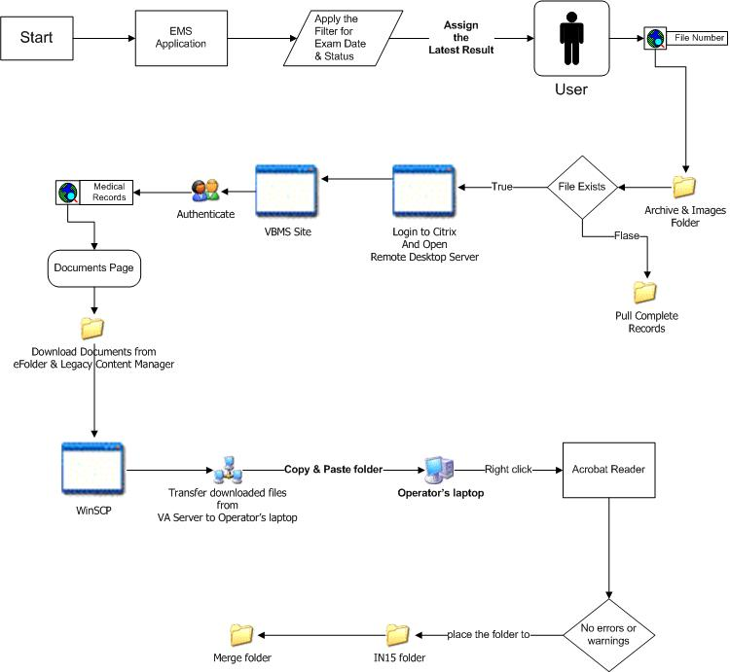

## Detailed AS IS Process Steps

Each Operator logs into VES system and VA server using smart card and a pin.

## EMS Application

1. From Operator’s laptop, open EMS application
2. Apply the filters for Exam Date and Status (Pending)
3. Open the latest result, and assign it to operator so that no one else will work on the case
4. Search for the File # in Archive Folder and Images Folder on the shared drive. If the file exists then Operator have to pull patient records from vbms site after the last processing date. If not, pull complete records

## VA Environment

1. Login to Citrix environment
2. Open Remote Desktop Server
3. Open Internet Explorer and go to vbms website
4. Authenticate with the user name, password and pin
5. Search for medical record using File #. Verify that the name and DOB match with the information from EMS application
6. Go to Documents
7. Manually download documents from 2 tabs – eFolder and Legacy Content Manager into a folder
8. Rename the folder with File # and Operators first name initials and last name
9. Open WinSCP and connect to Operator’s laptop
10. Transfer downloaded files from VA Server to Operator’s laptop

## Local environment

1. Copy and paste the folder from WinSCP folder to local folder in Operator’s laptop. Placing the folder in IN15 to Merge.
2. Right click on the folder and click on combine files using Acrobat Reader plugin. If there are no errors or warnings, place the folder in IN15 folder. Every 15 min, a program runs on this folder to merge the pdf files to one pdf file. This merged file is placed in Merge folder
3. Once the file is in Merge folder, copy the file to Archive folder and update the comment field in EMS application with the number of pages in merged PDF file

# **To BE Process Description**

This chapter highlights the expected design of the business process after automation.

## TO BE Detailed Process Map



## Detailed TO BE Process Steps

* Each Operator logs into VES Citrix environment with their username and password
* Bot will be installed in VES Citrix environment. Operator will start the automation process by double clicking the icon(batch file) on the desktop
* Bot will read entries from the file located at *file location*
  1. *Sample file:*
  2. Bot will compare username and MAC address from VES Server with the username and MAC address from the file to process the files
* WinSCP
  1. Open WinSCP
  2. Connect to VA Server WinSCP (*Assumption: All the details for connecting to VA server are saved in WinSCP*)
* Bot will retrieve login details (Password, station id) for VA Server from Orchestrator based on the user logged into VES environment
* Bot will open Citrix environment for VA server
  1. Bot will login to VA Server using the credentials retrieved from Orchestrator (Will this be from Orchestrator or pre-saved in users machine?)
  2. Bot will open Internet Explorer, enter URL for VBMS site *(URL Details)*
  3. Bot will log in to the VBMS site using the credentials (Username, Password, Pin, Station Id) from Orchestrator (Will this be from Orchestrator or pre-saved in users machine?)
  4. Bot will retrieve one unprocessed file number from the Excel and search for the documents in VBMS site. Go to Documents Tab:
     + Download files from eFolder tab
       - Capture total number of files in the tab
       - Retrieve Document Type and Subject from Orchestrator. Based on this, download the files to location *download path (This path will be same for all the operators)*
     + Download files from Legacy Content Manager tab
       - Capture total number of files in the tab
       - Retrieve Document Type and Subject from Orchestrator. Based on this, download the files to location *download path (This path will be same for all the operators)*

Note: Only 5 files can be selected at a time. When clicked on download, each of the file will be opened. Bot has to rename the file and save it. Files can be saved with any name. Ex: 1, 2, 3, etc.

* 1. WinSCP
     + Open WinSCP
     + Connect to VES Server WinSCP (*Assumption: All the details for connecting to VES server are saved in WinSCP)*
     + Move files from VA Server Download path to VES Server WinSCP Download path
* Copy file from WinSCP Download path to local folder
* Use combine files option from context menu of local folder to generate combined PDF in the same folder. Rename the file to File number
  1. Errors while combing files:
     + Signatures: Click on Combine Files
     + Password Protection: Click on combine files. When the password prompt appears, enter the possible passwords (Will be maintained in a file in Orchestrator). If all the provided passwords don’t work, place the folder in Errors folder and proceed with next record from the text file
     + Any other error: Open the PDF, click on lock icon, print the file to image. Optimize the file and replace the file in the folder. Try to combine the files again. If unsuccessful, place the folder in Errors folder and proceed with next record from the text file
* If Combine Files is successful, delete the individual files from Operators machine
* Move the merged file to Active Backup drive path
* Bot will set status of current file to complete and pick the next unprocessed file number from the text file for further processing
* Report and Email Notification:
  1. After all the files are processed, generate a report and email the report
  2. Report Format: *Please confirm*

|  |  |  |  |  |  |
| --- | --- | --- | --- | --- | --- |
| File number | Number of pages in eFolder | Number of pages in Legacy Content Manager | Number of pages in merged file | Status | Error message |
|  |  |  |  |  |  |
|  |  |  |  |  |  |

* 1. Email Format:

Hello

* Error message Logs:
  1. Log file will be maintained at *location*
  2. Success log: Log will be entered when the bot begins processing and completes the process the successfully
  3. Error Log: If there is an error in any step, a log will be entered
  4. Format: *Please confirm*

|  |  |  |  |  |
| --- | --- | --- | --- | --- |
| FILE NUMBER | ERROR_IND | LINE NO. | REPORT LINE | MESSAGE DATE TIME |
| 1234 | S | 1 | Process started for Veteran ID: | 5/28/19 6:40 |
| 1234 | S | 2 | Process ended successfully for Veteran ID: | 5/28/19 6:45 |
| 2345 | S | 1 | Process started for Veteran ID: | 5/28/19 6:41 |
| 2345 | E | 2 | Error in connecting to VA Server; Process ended | 5/28/19 6:42 |

## Parallel Initiatives/ Overlap (if case)

This chapter captures the proposed Business, Process & System changes in near future and its impact

|  |  |  |  |  |  |
| --- | --- | --- | --- | --- | --- |
| S.No | Initiative Name | Process Step(s) where it is identified | Impact on current automation request? How? | Expected Completion Date | Contact person for more details |
|  | n/a |  |  |  |  |

## In Scope for RPA

The activities **in scope of RPA**, are listed here:

* Install, validate and Configure Studio and Orchestrator for Development, QA and Production
* Development of bot:
  1. Read input file to retrieve file numbers
  2. Connect to VA Server
  3. Download documents(pdfs) from VA Server
  4. Upload pdfs to VES server
  5. Merge PDF files to one PDF
  6. Move the file to Active Backup folder
  7. Generate and email daily report with status
* Configure bot on Operators machine

## Out of Scope for RPA

Items that are deemed not in scope:

* Backup and recovery of systems, data or other configurations
* Changes required in existing backend applications for integration
* Upgrade and degrade of existing application for integration
* SSO with other parallel systems
* Data migration or data dumping for any file formats
* Overwriting existing system workflow
* Disaster Recovery remediation or replication of Active Directory data

## Business Exceptions Handling

The Business Process Owner and Business Analysts are expected to document below all the business exceptions identified in the automation process. These can be classified as:

|  |  |
| --- | --- |
| Known | Unknown |
| Previously encountered. A scenario is defined with clear actions and workarounds for each case. | New situation never encountered before. It can be caused by external factors. Cannot be predicted with precision, however if it occurs, it must be communicated to an authorized person for evaluation. |

#### Known Exceptions

The table below reflects all the business process exceptions captured during the process evaluation and documentation. These are **known exceptions,** met in practice before. For each of these exceptions, define a corresponding expected action that the robot should complete if it encounters the exception.

|  |  |  |  |  |
| --- | --- | --- | --- | --- |
| BE # | Exception name | Step | Parameters | Action to be taken |
| 1 | Error in reading file | n/a |  | End the process and notify the operator via email |
| 2 | Error in retrieving Orchestrator assets |  |  | End the process and notify the operator via email |
| 3 | Error connecting to Citrix environment |  |  | End the process and notify the operator via email |
| 4 | Error in downloading files |  |  | End the process and notify the operator via email |
| 5 | Error connecting to WinSCP |  |  | End the process and notify the operator via email |
| 6 | Error in merging pdf files |  |  | End the process and notify the operator via email |
| 7 | Error generating the report |  |  | End the process and notify the operator via email |
| 8 | Error sending an email |  |  |  |

#### Unknown Exceptions

For all the other **unanticipated or unknown business (process) exceptions**, the robot should:

Stop the process and capture the error in logs and daily report

## 

## Reporting

|  |  |  |  |  |
| --- | --- | --- | --- | --- |
| # | Report type | Update frequency | Details | Monitoring Tool to visualise the data |
| ***1*** | Process logs | Daily | How many times was this process run since the beginning of the month and what was the average run duration? | Kibana |
| ***2*** | Process logs | Monthly | How many robots worked on this process per each month? | Csv file posted daily on sharedrive |
| ***3*** | Transaction logs | Daily | How many transactions were run by this process since the beginning of the month and what was the average transaction duration? | Kibana |
| ***4*** | Error logs | Daily | Average number of errors by type per day | Kibana |
| ***5*** | Error logs | Daily | All errors per month grouped by type | Csv file posted daily on drive |

*\* For complex reporting requirements, include them into a separate document and attach it to the present documentation*

# **Other Observations**

Include below any other relevant observations you consider needed to be documented here.

*Example: Specific Business monitoring requirements (audit and reporting) etc*